+10

You can use Choreo (the constraint-honoring trajectory planner and editor) alongside WPILib to program autonomous path-following for a Romi differential drive robot. Because Romi uses a differential (tank) drive configuration [12.11], you can test time-optimal paths right on your desktop using simulation [12.11] before running them on the physical hardware. [1, 2, 3, 4, 5, 6] Open your Romi 2026 branch in VSCode and install the vendor dependency Choreo.
https://choreo.autos/lib/ChoreoLib2026.json
Getting Started with Choreo and WPILib
- Download and open the desktop application from Choreo Documentation.
- https://docs.wpilib.org/en/stable/docs/software/pathplanning/choreo/index.html

- Create a new project configured for a differential drivebase rather than swerve.
- Input your Romi's physical constraints (track width, max velocity, and max acceleration) into the profile settings. [1, 2, 3]
To setup and optimize paths for a Romi robot in Choreo, populate the Robot Configuration panel using these parameters based on official Pololu Romi specifications and standard WPILib dynamics:

1. Drivebase Type
- Drive Type: Differential / Tank [cite: 1.1.1]

2. Robot Dimensions
- Trackwidth: 0.141 m (5.55 in)
- Wheelbase / Length: 0.163 m (6.4 in chassis length)
- Bumper Front/ Bumper Back: 3.2 in
- Bumper Side: 3 in
- Bumper / Outer Width: 0.149 m (5.86 in)
- Bumper / Outer Length: 0.163 m (6.4 in)
- Wheel Radius: (17.5 mm / 1.375 in radius)

3. Physical & Inertial Parameters
- Mass: ~0.45 kg to 0.55 kg (depends on whether you have a Raspberry Pi and batteries installed; standard stock weight is ~0.48 kg)
- Moment of Inertia ($\text{MoI}$): ~0.002 kg·m² (estimated assuming a uniform cylinder $I = \frac{1}{2} M R^2$)

4. Powertrain & Motors
- Motor Rev/Wheel Rev: 120.0 (120:1 standard Romi motor gear reduction)
- Drive Motor Type: Romi / Pololu 120:1 Mini Plastic Gearmotor
- Motor Free Speed: ~150 RPM at 4.5V output [cite: 2.1.1]
- Motor Max Speed: 100 RPM
- Max Velocity: ~0.5 m/s to 0.6 m/s (or set a soft limit around 0.4 m/s in Choreo to give headroom for PID feedback loops) [cite: 1.2.1]
- Max Torque / Acceleration:
  - Stall Torque: 0.1765 N·m [cite: 2.1.1]
  - Max Linear Acceleration: ~1.0 m/s² to 1.5 m/s² (due to low motor power and battery drop)
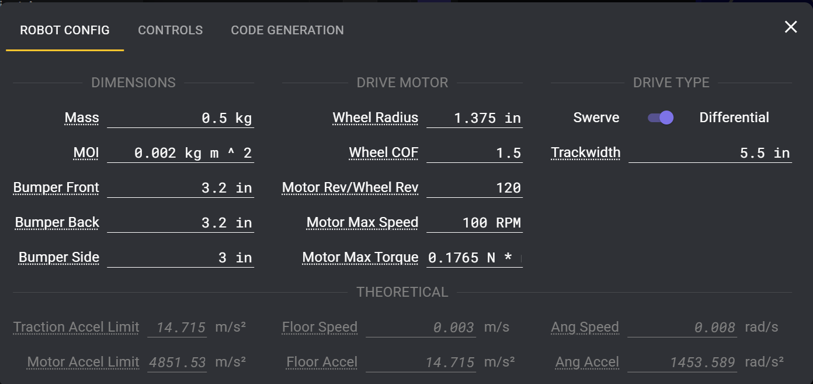

Recommended Tuning Tip
When exporting your Choreo trajectory into code, run SysId or start with a 20–30% safety margin on maximum velocity and torque [cite: 1.2.1]. Because the Romi runs on AA batteries and experience voltage sags, lowering the max linear speed to 0.35 - 0.40 m/s will ensure path-following controllers (like RamseteController or PPHolonomicDriveController) have enough headroom to correct for drift [cite: 1.2.1].

Exporting and Project Setup
- Draw your desired autonomous path using waypoints and constraints inside the Choreo UI.
- Configure code generation to output trajectory files directly into your WPILib project directory (e.g., src/main/deploy/choreo or equivalent Java/C++ source folders).
- Ensure your Romi project is set up using the standard WPILib VS Code extension. [1, 2, 3, 4, 5]
Simulating and Running on Romi
- Build your robot code containing the path-following logic using ChoreoLib or WPILib trajectory utilities.
- Power on your Romi and connect your computer to its broadcasted WPILibPi-<number> Wi-Fi network [12.11].
- Open the WPILib Command Palette (Ctrl + Shift + P) in VS Code and launch Simulate Robot Code (F5) to watch your desktop code drive the physical Romi through your Choreo-optimized path. [1, 2, 3, 4, 5]
Watch this video to understand the layout and structure of a WPILib Romi example project:

https://www.youtube.com/watch?v=j5g4nHV3FaY

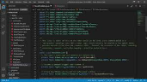
8m

Romi WPILib Example Project Walkthrough

2.5K views · 5 years ago
YouTube · Spectrum3847

